Everything you need to know about KL divergence? - the loss function at the heart of machine learning

First thing first, as you may know most of machine learning is estimating a probability distribution from a finite number of samples. But to do that we need to know when we have properly estimated a distribution. But wait! What do you mean when you say ‘we have estimated the distribution’?

I can say by this statement I mean, no we kind of know a distribution which is very similar to the some distribution (p(x)). And this is where the core question is?What does it even mean to say two probability distributions are "similar" or “different”?.

One simple answer that pops up in everyone’s mind, ohh why not just subtract the distributions. Take p(x) − q(x) at each point and add up the sizes. Tbh it is not crazy, it is a real distance and it’s called total variation. But it has a flaw that matters enormously in Machine Learning.

It treats all the errors with equal importance, for example: being off by 0.1, when p(x)=0.5 is treated same as being off by 0.1 when p(x)=0.0001. I will explain in a bit why this is an issue. So majority of the samples that we see will be coming from regions with higher probability, so if we somehow get it right majority of the time and for that we would like to prioritize being correct on majority of the samples. For example if you see the figure below, the absolute gap between two differences is equal, but you can clearly see from the image on the left, that the distribution q1 is more close to the actual distribution p. Note: (doubtful) This may not be always true, as sometimes being correct on rare samples takes much more importance than being correct in general, in that we would like to prioritize the difference on rare samples, but subtraction is not the way to do it, we would just like to weigh those samples more.
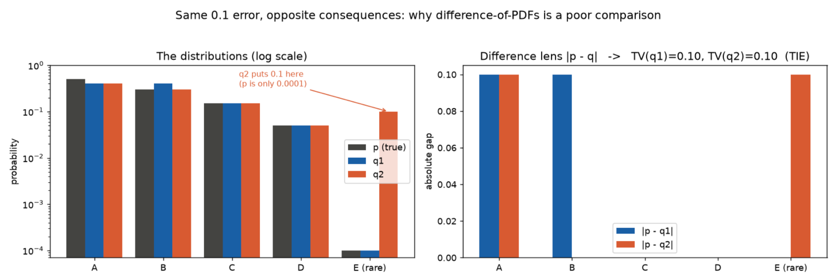

Alternatively, those are not the same mistake. If the truth says an event essentially never happens and your model gives it real probability, that is a serious error — and worse, if the truth says an event does happen and your model assigns it probability zero, your model is claiming something impossible is real. A plain difference barely notices that; it just sees a small gap.

Instead what we would like to have is a measure which autoscales itself based on how big is the blunder, so how does p/q sound? If p is very small, the penalty is small even if the blunder by q is very big. Talking about independent samples, they multiply probability as you might already know, but here we would prefer our score to add, kind of similar to we accumulate how much mistakes it’s making for every single sample. differences don't respect products, logs turn products into sums. Two clues, one answer: you want the log of a ratio or something similar

Before going for KL, let’s bring in the concept of Surprise, entropy, cross-entropy.

Surprise is simple: How surprised should you be when something with probability p happens? If something is really obvious, then you will not really be surprised right? For example if someone says, sun rises in the east, you will be like yes i know (infact everyone knows that). But what if someone says, today there is gonna be an eclipse, then you will definitely be more surprised as there is some new rare information that is there and the event is also occasional, now what if someone says today the sun will rise from the west (you will go nuts right?), even though the probability of this happening is nearly zero, if it happens the surprise will be just crazy (infinite).

Now visualize a function which gives very very small values near one and very big values near 0 and yes you guessed it correctly: it’s Suprise(x) = - ln (p(x)), you can also in a sense say how much information is x carrying. That’s why when you change the log from ln to log2 it is called as bits required to store this information.
Now suppose what if i want to describe a whole distribution by how much it can surprise me, then we will go for something like expectation of surprise (average), which is given by:
Avg Surprise = H(p) = Σ p(x)·(−ln p(x)), It is also called the entropy (randomness) of the distribution.

That's also the fewest bits per symbol any code built with full knowledge of p can average — the best you could ever do (we will have to change ln to log2 obv).

Now suppose you only have model q. Every draw you feel surprise −ln q(x), but x still comes from the real p, then:
H(p,q) = Σ p(x)·(−ln q(x))

If you analyze closely, you will see if x is very probable in p and less probable in q, the both p(x) and -log(q(x)) has large values. Also if x is very less probable in x and very probable in q then they go towards small value (less importance as we discussed earlier).

Average bits actually paid, using a code built for q, on data that really comes from p. If q = p this collapses to H(p). If q is wrong, you overpay, every time. In simpler language what we are trying to do is to store all the information that is there in the distribution p into our model distribution q.

KL is just the size of this overpay. So the best we can do is H(p) right? And the cost is H(p,q)

Then the price = H(p,q) - H(p) = Σ p(x)·(−ln q(x)) - Σ p(x)·(−ln p(x))
= - Σ p(x) (ln q(x) - ln p(x))
= - Σ p(x)ln(q(x)/p(x))

KL(p‖q) = H(p,q) − H(p) = Σ p(x)·log(p(x)/q(x))

It was Not invented — we forced it. It's "how many extra bits does believing q cost me, relative to the best I could ever do." Following is an example of where we loose the bits:
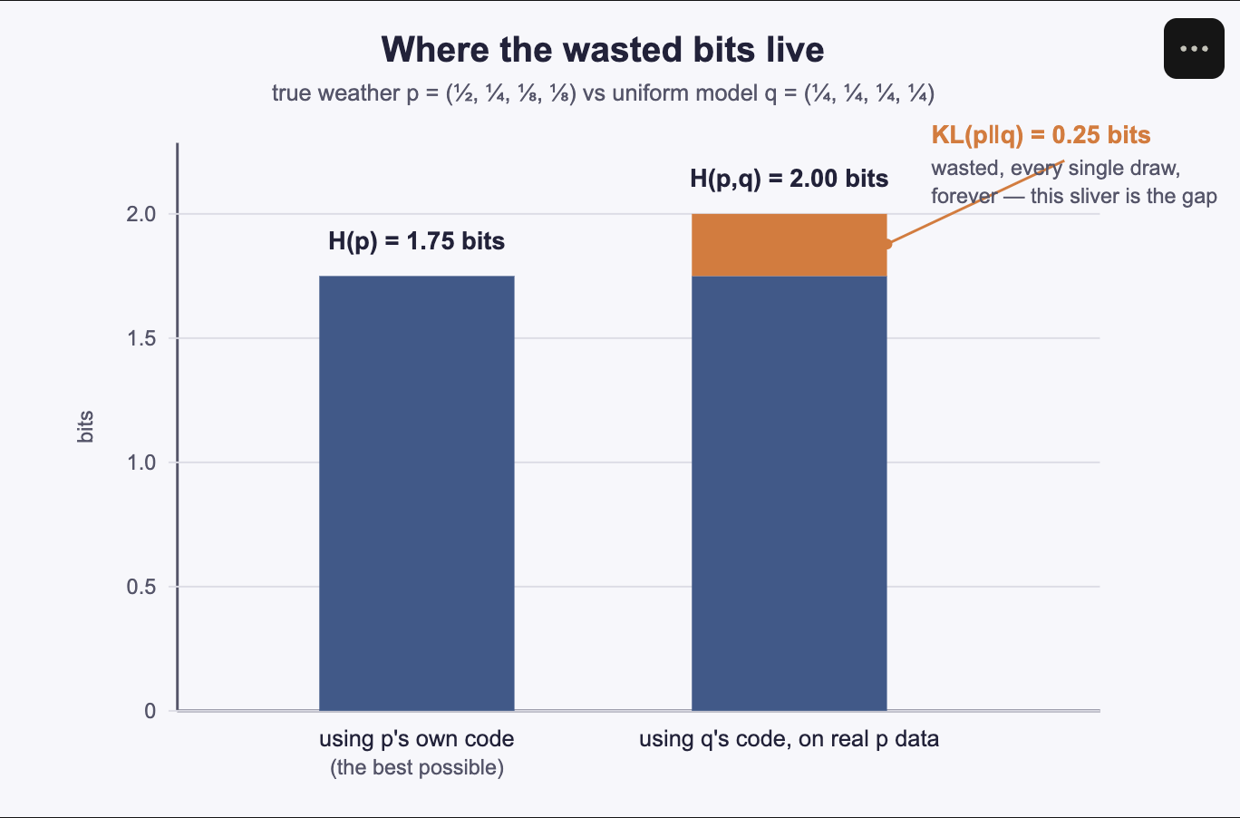
There is another interesting property, KL divergence is always >= 0, the proof is trivial. One-line proof that KL ≥ 0, Jensen's inequality on the convex function −log:
KL(p‖q) = E_p[−log(q/p)] ≥ −log(E_p[q/p]) = −log(Σ q) = −log 1 = 0
Equality only when q = p everywhere — a model can never beat the truth's own entropy, only match it. And if p(x) > 0 somewhere q says is impossible (q(x)=0), KL blows up to infinity: ruling out something that actually happens is infinitely costly under forward KL. That's the real reason softmax never outputs a hard zero, and why label smoothing exists.

Another interesting property is the the asymmetry and it originates from the the same place. KL is an average of log(p/q), and an average needs a weighting distribution. Forward KL(p‖q) weights by p, so it only "cares" about places where p is large (more likely things). But Reverse KL(q‖p) weights by q, so it only cares about where q is large (less frequent event). Same ratio, different vantage point — that's the whole source of the asymmetry, and it's also why KL fails two of the three rules for being a true distance metric (not symmetric, no triangle inequality — it's a divergence, not a metric; when you need a symmetric, bounded fix, that's Jensen-Shannon divergence, which is what the original GAN objective minimizes).
To see the more clear difference between these two KL divergences, let’s take an interesting example. We will try to model a p (with two modes or peaks) with a model q (which is a true gaussian). Now if we go with the forward KL, it will try to minimize the KL divergence at places of maximum p -> so it would want q to have higher where p is higher, it will not dare to put q(x)=0 where p is non zero.
Similarly, if we take into account the reverse KL, it goes the other way: it will try to get a right at cases which are less likely -> so it will try to align q small where p is small. You will get a better idea if you see the figure:
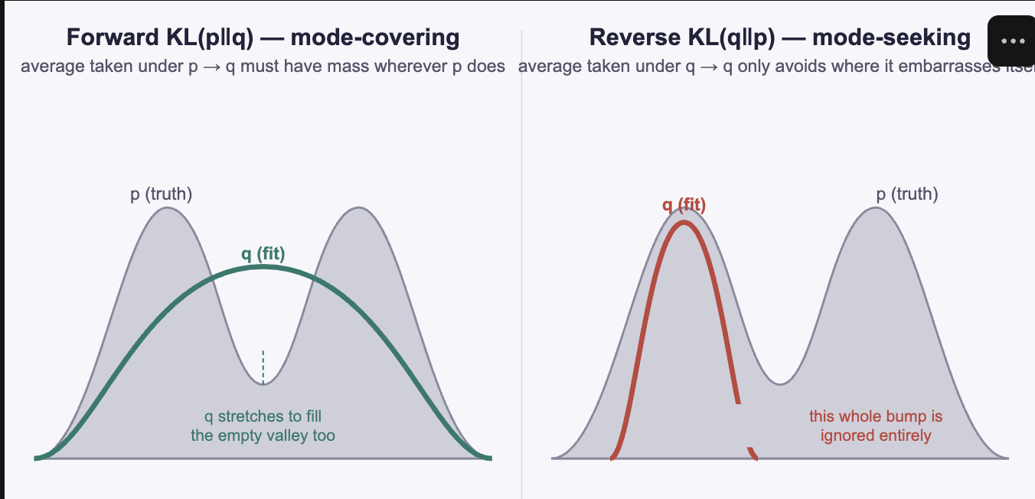
Forward KL is what maximum likelihood does (classifiers, language models, most supervised learning) — it hedges, and tries to cover everything. Reverse KL is what variational inference and VAEs do (the tractable direction) — it collapses onto one mode, which is the textbook explanation for blurry VAE samples and under-covering posteriors.

You might have never noticed it but KL was already running your training loops
You never actually have the true p — only samples. Define the empirical distribution p_data: equal mass on every observed example, zero elsewhere (7 heads in 10 flips → p_data = (0.7, 0.3)). This stands in for "the truth" in every practical setting. Maximum likelihood estimation is: pick parameters that make the observed data least surprising to the model.
maximize Π q(xᵢ)
= minimize −(1/N)·Σ log q(xᵢ) (average negative log-likelihood)
= minimize H(p_data, q) (cross-entropy)
Since H(p_data, q) = H(p_data) + KL(p_data‖q), and H(p_data) has no model parameters in it — it's just a constant — minimizing cross-entropy and minimizing KL(p_data‖q) are literally the same optimization. MLE is forward-KL minimization, which is why it's mode-covering.

For classification specifically, the true label is one-hot, so H(p) = 0 exactly, and:
cross-entropy loss = H(p,q) = H(p) + KL(p‖q) = KL(p‖q)
The classifier or language-model loss you've been minimizing this whole time isn't "like" KL divergence — it is KL divergence, exactly, with the constant subtracted off.
Moveover, KL is just one member of the f-divergence family: you can create your own, just
pick any convex f with f(1)=0, define D_f(p‖q) = Σ q(x)·f(p(x)/q(x)). Non-negativity and "zero iff p=q" come free from convexity + Jensen for every member — never a KL-specific fact.
f(t) = t·log t → KL(p‖q), forward
f(t) = −log t → KL(q‖p), reverse
f(t) = ½|t−1| → total variation
f(t) = (t−1)² → chi-squared
Mutual information also turns out to be exactly a KL: I(X;Y) = KL(p(x,y) ‖ p(x)p(y)) — how far the true joint is from the pretend-independent world. That single identity is why MI is automatically ≥ 0 and automatically 0 only when X, Y are independent, with no separate proof needed.
There are Other ways of looking at entropy and information
Everything above builds entropy from one route — an axiomatic notion of "surprise." That's Shannon's cleanest route, but there are other where from which the same number falls out of unrelated arguments. But that’s for some other blog!
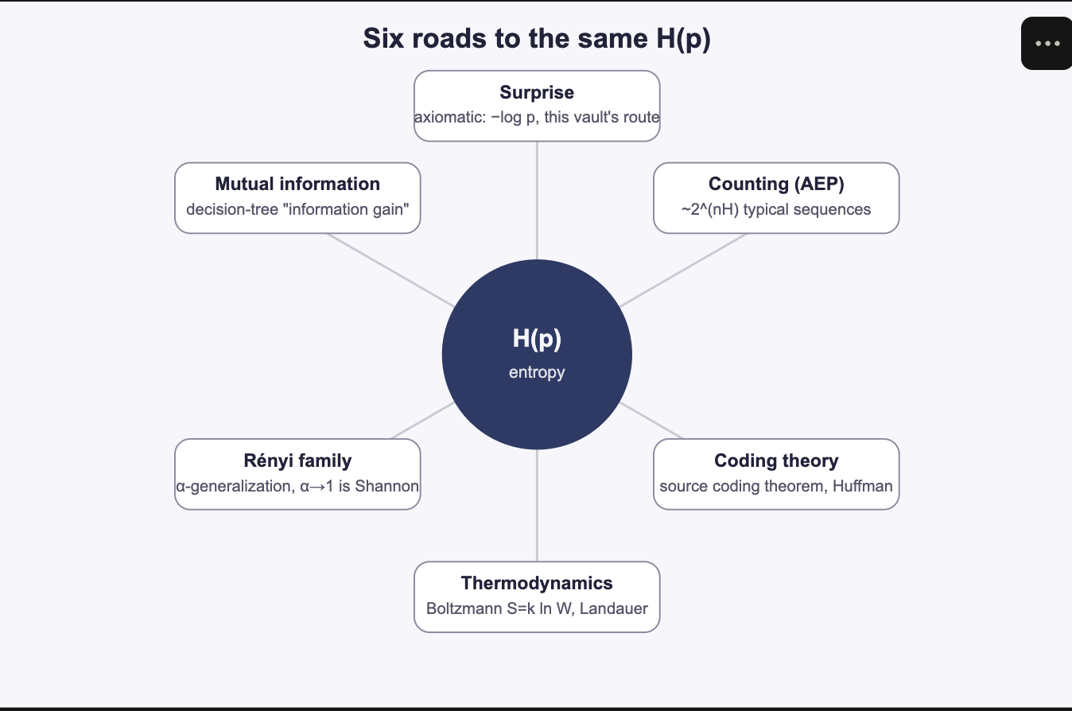
Have a great day! Happy Learning

